Friends of
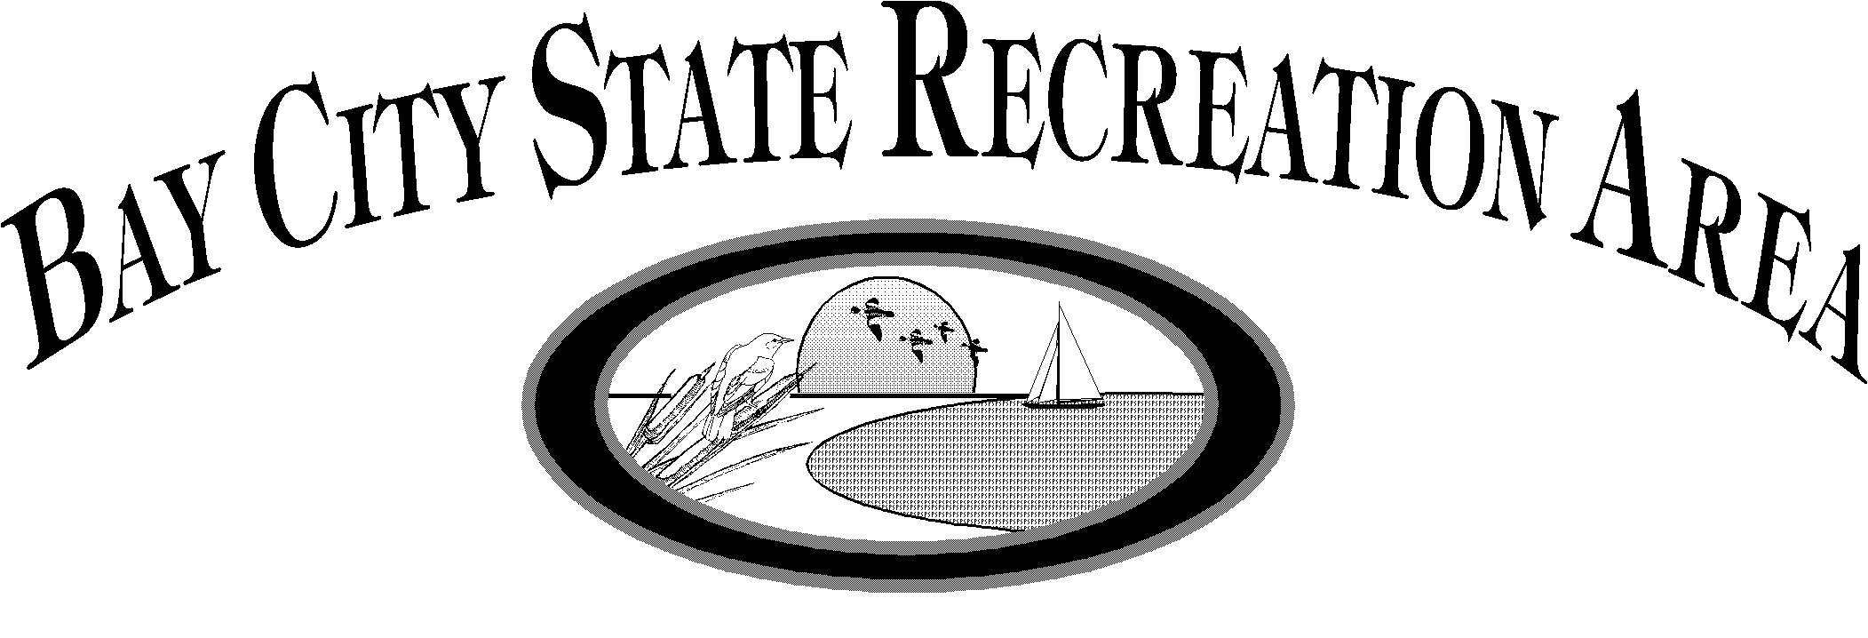

Saginaw Bay Visitor Center
3582 State Park Drive, Bay City, MI 48706
Phone: (989) 667-0717, Fax: (989) 667-0742

Date: January 2016
To: Potential Saginaw Bay Waterfowl Festival Exhibitors
From: Valerie E. Blaschka, Park Interpreter
RE: Arts & Crafts Show, August 6, 10AM to 6PM & August 7, 9AM to 4PM

On Saturday and Sunday, August 6 and 7, 2016, we will be hosting the 21st annual Saginaw Bay Waterfowl Festival at Bay City State Recreation Area. We would like to extend this invitation to you to participate in this exciting weekend event as an exhibitor in the Arts & Crafts Show. The mission of the Saginaw Bay Waterfowl Festival is to help participants become more aware of Michigan's waterfowl resources, the sport of waterfowl hunting, and the need to conserve these valuable natural resources and the wetland habitat upon which they depend. Last year over 13,500 visitors attended this event! A new record!

We are keeping the exhibit fees low at $20.00 per space. Free overnight “camping” for exhibitors may be done in your RV, van or camper in the reserve parking area (modern campsites can be reserved in the State Park Campground by calling 1-800-44-PARKS). Evening security will be provided by night rangers and committee personnel will be camping out overnight in the exhibition area. This family-focused event is free of admission to visitors; however as in all Michigan State Parks, a Recreation Passport is required on all vehicles entering the park (including yours). Passports may be purchased by checking “YES” when you renew your license plate or at park entrance ($11 state residents). Recreation Passports are also available at the Park Office. The Recreation passport is good at all Michigan State Parks, DNR Boating Access sites and State Forest.

We hope that you will be interested in participating in this exciting event as an exhibitor. Early registration for exhibit space is encouraged. This year our goal is to have all booth spaces paid for by June 15.

We hope that you will come out and be a part of the Saginaw Bay Waterfowl Festival and become a part of exposing Michigan's citizens to the beauty of Michigan's wildlife resources! If you have any questions regarding the event, you can reach me at the above address and phone or e-mail me at blaschkav@michigan.gov.

Rules for State Park are on the website: www.friendsofthepark.org
2016 Saginaw Bay Waterfowl Festival - Wildlife Art & Craft Show
Mailing Address & Rules

Please fill out the form on the following page and mail it to:
Saginaw Bay Visitor Center
3582 State Park Drive
Bay City, MI 48706
Attn: Friends

Send money order or checks payable to: Friends of BCSRA
Please do not send cash via mail!

Questions: Contact:
Intern, Bay City State Recreation Area
(989) 667-0717, E-mail: waterfowlfestival@sbcglobal.net

Valerie Blaschka, Park Interpreter, Bay City State Recreation Area
(989) 667-0717, E-mail: blaschkav@michigan.gov

Booth Assignment:
The booths will be allocated on a first come first served basis, so it will be an advantage to act quickly. You may request a specific booth space if you have attended the festival in previous years, but your requested space is not guaranteed if you do not register before another exhibitor that has requested that space. The booths are APPROXIMATELY 12' to 15’ wide by 10’ to 20' deep (depending on available space) and they do not have electrical outlets available. In the case where multiple booths are applied for, the Friends reserve the right to allocate other space as close as possible to the space indicated by the exhibitor. Booths will be located on the lawn adjacent to the paved Tobico Lagoon Trail between the Floating Fishing Dock and the Picnic Shelter.

Wildlife Art & Craft Show Exhibitor Rules:

    - All exhibitors must check-in at the Welcome Booth for verification of space assignment BEFORE setting up.
    - At least 30% of your art and craftwork must be inspired by nature's beauty or crafted from natural products. (Bird houses & Bird feeders will be accepted)
    - All items must be hand crafted: (Prints made from original art work & photography will be accepted)
    - All exhibitors are expected to occupy their booth: 10AM-6PM Saturday and 9AM-4PM Sunday.
    - ABSOLUTELY NO VEHICLES WILL BE ALLOWED IN THE EXHIBITION AREA AFTER THE EVENT BEGINS. THIS WILL BE STRICTLY ENFORCED FOR THE 2016 FESTIVAL. All vehicles must be moved to parking area during hours of operation.
    - Please do not move you or your crafts into the site next to you without permission.
    - A Recreation Passport is required on all vehicles entering the park (per State law). Daily Motor vehicle permits for out-of-state visitors will be $9 daily, or $31 annual for park entrance fee. Michigan resident State Park Recreation Passport fee is $11 when renewing your vehicle registration with the Secretary of State. Recreation Passports are also available at the Park Office. The Recreation Passport is good at all Michigan State Parks, DNR Boating Access sites and State Forest.
    - Overnight "camping" may be done in your RV, van or camper in the reserve parking area, at no additional charge. NO fires will be allowed in this area. Visitor Center restrooms available close by. Make modern campsite reservations by calling 1-800-44-PARKS.
    - Violators will not be invited back again to participate.
    - The Bay City State Recreation Area, Michigan DNR, US Fish & Wildlife Agency, and the Michigan Duck Hunters Assoc., are not responsible for lost and/or stolen property during and/or after the festival.
    - Please pick up your trash at the end of each day.

2016 Saginaw Bay Waterfowl Festival - Wildlife Art & Craft Show
Application & Reservation for Exhibit Space
PLEASE RETURN THIS FORM WITH YOUR PAYMENT

Products to be exhibited (check one)*:

_____Wildlife Art Prints, Paintings, photographs & Lithographs
_____Wild Life Wood Crafts, also, 30% Wildlife Wood crafts can also be combined with Halloween Wood Crafts
_____Wildlife Ceramics and Sculptures
_____Wildlife Home Decorations
_____Wildlife Material: Sewing, Quilting, Applique, Monogrammed Apparel, Apparel Art.
_____Water Resource & Nautical oriented decorations
_____Natural products – honey, maple syrup
_____Candles & Soap
_____Stone Crafts
_____Other (please describe):

*items displayed shall be limited to those which reflect the beauty and appeal of wildlife and Michigan's great out-of-doors.

Registration Fee:
Number of spaces requested: _______x $20.00 = _________

_________ Site Preference (for those exhibitors who are returning; space is still first come, first serve)

State Park Recreation Passport is required on any vehicles entering the park (per State law). Check “YES” when you renew your license plate. Learn more at www.michigan.gov/recreationpassport. Michigan residents may purchase a Recreation Passport for $11 at the park entrance. Recreation Passports are also available at the Park Office. The Recreation passport is good at all Michigan State Parks, DNR Boating Access sites and State Forests.

Please enclose a stamped self-addressed envelope if you wish to receive written confirmation for your exhibition space. Otherwise you will be sent an e-mail within a month of receipt of payment. A phone message may be left if these options are unavailable to us.

Business/Applicant Name:

Address:

City, State, Zip:

Telephone: E-mail:

I have read and understand the rules on page 2 and the rules for the State Park online at www.friendsofthepark.org.

Signature:

